

Intermolecular Forces and Gases
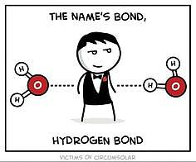


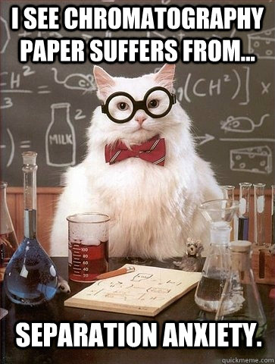
(Burgess n.d.)

(Admin, I See Chromatography Paper Cat Meme 2014) (Admin, Covalent Bond Cartoon Wallpapers 2015)
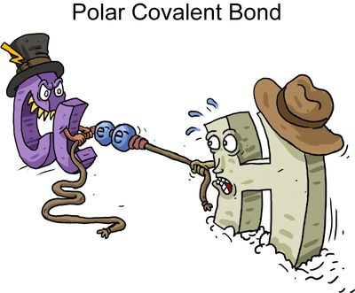
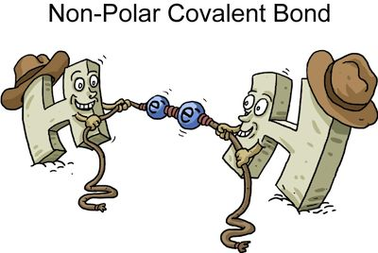

(Ramos n.d.)

Week | Outcomes | References and tasks | Assessments
Term 3  Wk  2-3 | - the valence shell electron pair repulsion (VSEPR) theory and Lewis structure diagrams can be used to explain, predict and draw the shapes of molecules  - the polarity of molecules can be explained and predicted using knowledge of molecular shape, understanding of symmetry, and comparison of the electronegativity of atoms involved in the bond formation | Lucarelli Set 11 q 3  Lucarelli Set 12 q 5  Lucarelli Set 24 q1-8 | Task 9:  Practical test- Post laboratory test 2  Task 10: Investigation- Chromatography to analyse intermolecular forces  Task 11: Test- Intermolecular forces and gases
4-5 | - the shape and polarity of molecules can be used to explain and predict the nature and strength of intermolecular forces, including dispersion forces, dipole-dipole forces and hydrogen bonding  - observable properties, including vapour pressure, melting point, boiling point and solubility, can be explained by considering the nature and strength of intermolecular forces within a covalent molecular substance | Lucarelli Set 25  q1-13, 15-16  STAWA Experiment 14  STAWA Experiment 15
6-7 | - data from chromatography techniques, including thin layer chromatography (TLC), gas chromatography (GC), and high-performance liquid chromatography (HPLC), can be used to determine the composition and purity of substances; the separation of the components is caused by the variation in strength of the interactions between atoms, molecules or ions in the mobile and stationary phases  - the behaviour of an ideal gas, including the qualitative relationships between pressure, temperature and volume, can be explained using the Kinetic Theory  - the mole concept can be used to calculate the mass of substances and volume of gases (at standard temperature and pressure) involved in a chemical reaction | Lucarelli Set 33 q 1-10  Lucarelli Set 1  q1-7, 10-13  Lucarelli Set 16 q 6-11  Lucarelli Set 18 q1-7

In addition the following outcomes will need to be mastered in order to pass this course.

Science Inquiry Skills
- identify, research, construct and refine questions for investigation; propose hypotheses; and predict possible outcomes
- design investigations, including the procedure(s) to be followed, the materials required, and the type and amount of primary and/or secondary data to be collected; conduct risk assessments; and consider research ethics
- conduct investigations safely, competently and methodically for the collection of valid and reliable data, including: chromatography, measuring pH, rate of reaction, identification of the products of reactions, and determination of solubilities of ionic compounds to recognise patterns in solubility
- represent data in meaningful and useful ways, including using appropriate graphic representations and correct units and symbols; organise and process data to identify trends, patterns and relationships; identify sources of random and systematic error; identify anomalous data; estimate the effect of error on measured results; and select, synthesise and use evidence to make and justify conclusions
- interpret a range of scientific and media texts, and evaluate processes, claims and conclusions by considering the quality of available evidence; and use reasoning to construct scientific arguments
- communicate to specific audiences and for specific purposes using appropriate language, nomenclature and formats, including scientific reports

Lewis Structures (Electron Dot Diagrams)
Lewis Structures: valence electrons in an atom, molecule or ion are shown as a dot or cross (a line can be used to represent a pair of electrons but this is usually reserved for molecules or polyatomic ions). Rules are found in Essential Chemistry pg 50 (atoms), 56 (ionic compounds) 59 (molecular substances- very important) and pg 60 (polyatomic ions).
Examples:
Atoms: hydrogen atom aluminium atom bromine atom

Monatomic ions: sodium ion strontium ion phosphide ion

Covalent molecules: Cl₂ CO₂ HCN

Polyatomic Ions: OH⁻ NO₃⁻ NH₄⁺

Molecular Shapes
The shapes of covalent molecules are due to the repulsions between groups of valence electrons around the central atom. This is known as the valence shell electron pair repulsion (VSEPR) theory. The electrons (and hence, atoms) arrange themselves so as to minimise the repulsion between them.
When determining shapes, double and triple bonds are treated as though they are a single group of electrons (in reality they have a slightly greater impact on repulsion between electron pairs and, as such, impact bond angles).
Shape | Diagram | Number and types of valence electron groups | Bond Angle | Examples
Linear |  | 1 or 2 groups of electrons | 180° | F₂, CO₂, etc
Bent (V-shaped) |  | 4 groups and two are lone pairs | ≈104.5° | H₂O, SO₂, etc
Triangular planar |  | 3 groups and none are lone pairs | 120° | CH₂O, SO₃, etc
Pyramidal |  | 4 groups and one is a lone pair | ≈107° | NH₃, PCl₃, etc
Tetrahedral |  | 4 groups and none are lone pairs | 109.5° | CH₄, SiBr₄, etc

Example: Draw the Lewis structures of the following molecules and ions and name their shape.
CO, CS₂, CH₂Cl₂, H₂S, PF₃, O₃, CO₃²⁻, SO₄²⁻, SO₃²⁻

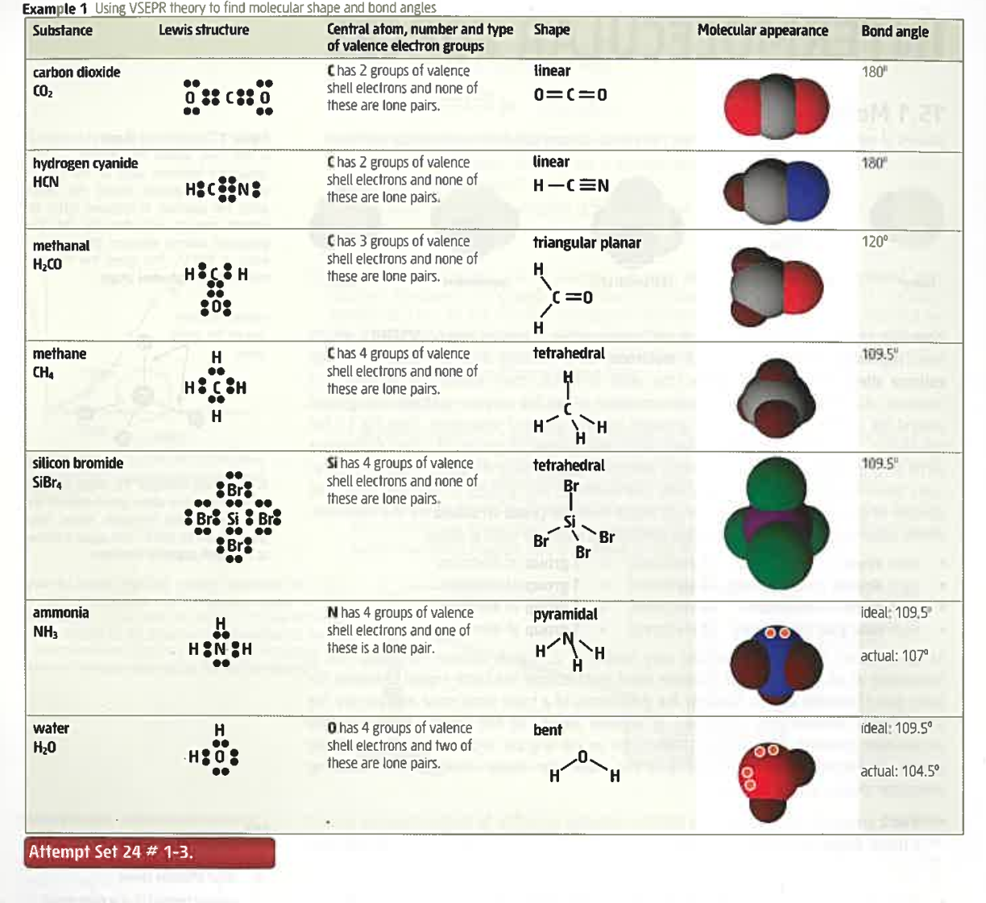

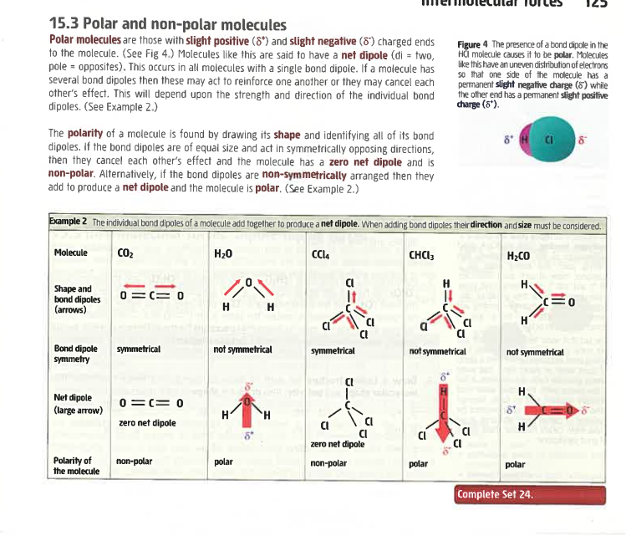

Polar Bonds and Molecules
Electronegativity is an atom’s tendency to attract electrons.

Polar bond ____________________________________________________________________ ________________________________________________________________________________________________________________________________________________________________________________________________________________________________________________________________________________________________________________________

Polar/ non-polar molecules
A molecule with multiple polar bonds may or may not be polar. It is dependent on the size and position of the polar bonds. A molecule will be polar if the vector sum (ie size and direction) of the individual bond dipoles gives an overall net dipole.

Example: For each of the following molecules draw in the polar bonds and determine if the molecule is polar or non-polar.
CO, CS₂, CH₄, CH₃Cl, CH₂Cl₂, CHCl₃, CCl₄,H₂S, PF₃, O₃

Intermolecular Forces (Van der Waals forces)
Intramolecular forces _____________________________________________________________ ____________________________________________________________________________________________________________________________________________________________

Intermolecular forces _____________________________________________________________ ________________________________________________________________________________________________________________________________________________________________________________________________________________________________________________________________________________________________________________________

- Dispersion Forces- occur between all molecules but are most significant in non-polar substances and monatomic gases. It is due to the random motion of shared valence electrons which are not symmetrically shared and so can produce a temporary dipole. This temporary dipole can then induce temporary dipoles in nearby molecules. These dipoles then experience weak electrostatic attractive forces called dispersion forces. As the induced dipoles are temporary, they are constantly appearing then disappearing and then reappearing somewhere else.

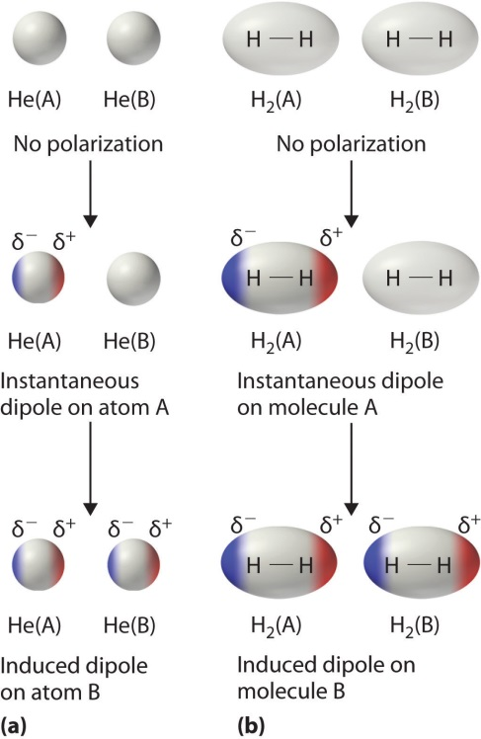

Strength of dispersion forces ____________________________________________________ ____________________________________________________________________________________________________________________________________________________________________________________________________________________________________
Molecule | Melting Point (°C) | Boiling Point (°C)
F₂ | -220 | -188
Cl₂ | -101 | -35
Br₂ | -7 | 59
I₂ | 114 | 184

____________________________________________________________________________________________________________________________________________________________________________________________________________________________________________________________________________________________________________________________________________________________________________________________
Molecule | Melting Point (°C) | Boiling Point (°C)
Pentane | -130 | 36
Methybutane | -160 | 28
Dimethylpropane | -18 | 9.5

- Dipole-Dipole Forces – occur between polar molecules. It is due to the electrostatic attraction between oppositely charged ends of the overall dipole. Substances with polar molecules have slightly higher melting and boiling points than other substances of similar molecular size that have non-polar molecules.

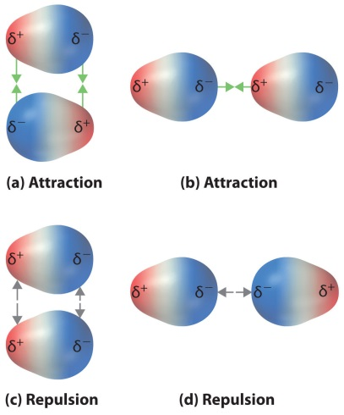
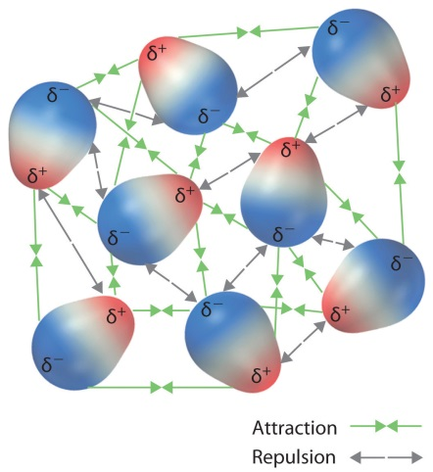

Strength of dipole-dipole forces:
The strength of a dipole moment increases with the increased difference in electronegativities between the atoms in the molecule.

Although the strength of a dipole moment increases with the increased difference in electronegativities between the atoms in the molecule, the dispersion forces become more significant with increasing number of electrons (size of molecule). This adds to the intermolecular forces and increases the melting and boiling points.

Molecule | Melting Point (°C) | Boiling Point (°C)
CH₃F | -138 | -79
CH₃Cl | -97 | -24
CH₃Br | -93 | 3
CH₃I | -66 | 42

- Hydrogen Bonding ___________________________________________________________ ________________________________________________________________________________________________________________________________________________________________________________________________________________________________________________________________________________________________________________________________________________________________________________________________________________________________________________________________________

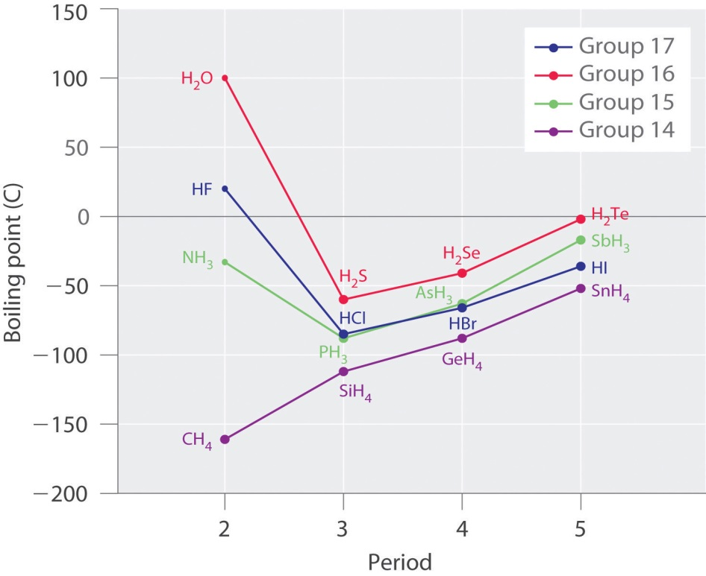

(Larsen n.d.)

Significance of water
Boiling and melting points of hydrogen bonded substances tend to be much higher than those of substances of similar molecular size that display only dipole-dipole or dispersion forces.
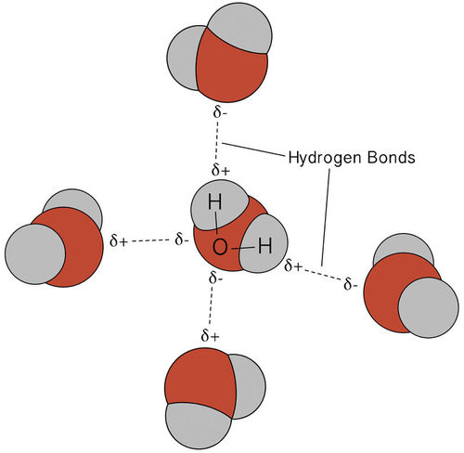
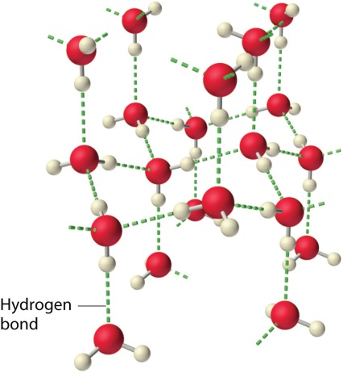
Water has the highest melting point as its molecular arrangement allows each water molecule to form up to four hydrogen bonds whilst HF and NH₃ typically form only two hydrogen bonds with other molecules.

Alcohols and carboxylic acids are also capable of hydrogen bonding.

Alcohols

Methanol | Ethanol | Propan-1-ol | Butan-1-ol
Carboxylic acids

Methanoic acid | Ethanoic acid | Propanoic acid | Butanoic acid

Solubility
A solute will be soluble in a solvent if the solute- solvent intermolecular forces are of similar strength (or stronger) to the solute- solute intermolecular forces and to the solvent-solvent intermolecular forces.
Eg Dissolving ethanol in water
Solvent = water : most significant solvent -solvent intermolecular force is hydrogen bonding.
Solute = ethanol : most significant solute- solute intermolecular force is hydrogen bonding.
The solute- solvent intermolecular force that can exist between ethanol and water is hydrogen bonding so ethanol will be soluble in water.
Draw a diagram to show the hydrogen bonds that can form between water and ethanol.

Chromatography – an analytical technique used to separate and identify components (or analytes) of mixtures. It can also be used to determine the concentration of these components in the mixture. The principles of the various types of chromatography are the same. That is:
- The mixture is placed into a mobile phase (this may be a liquid solvent or a gas stream)
- The mobile phase containing the mixture is passed over a stationary phase
- The different components in the mixture adsorb to the stationary phase at different points in time depending on the nature of the stationary phase and the analytes in the mixture.
There are a few different types of chromatography that can be used to identify the analytes (or components) in a mixture.
- Thin Layer Chromatography (TLC)
  - Used for organic mixtures such as plant pigments and drugs.
  - A thin glass plate is coated with finely powdered alumina, Al₂O₃ or silica SiO₂ which acts as the stationary phase.
  - The mobile phase is a solvent that will dissolve and separate the components of the mixture.
  - The mobile phase moves up the stationary phase by capillary action.
  - The TLC plate and solvent are placed in a sealed container to ensure the vapour phase is saturated with gaseous solvent particles and to prevent the solvent evaporating.
  - Due to the difference in polarity of the analytes they are carried up the stationary phase at different rates and adsorb at different points.
  - The components in the mixture can be identified by their retardation factor, R_{f} where:
R_{f} =
  - In TLC, the R_{f} of a given substance is not constant as it depends on the nature of the stationary and mobile phases. For this reason a TLC of the different pure substances thought to be present in the mixture needs to be produced under identical conditions in order to obtain comparable R_{f} values.
  - TLC has the advantage of being a relatively simple and inexpensive way of confirming the purity of a mixture.
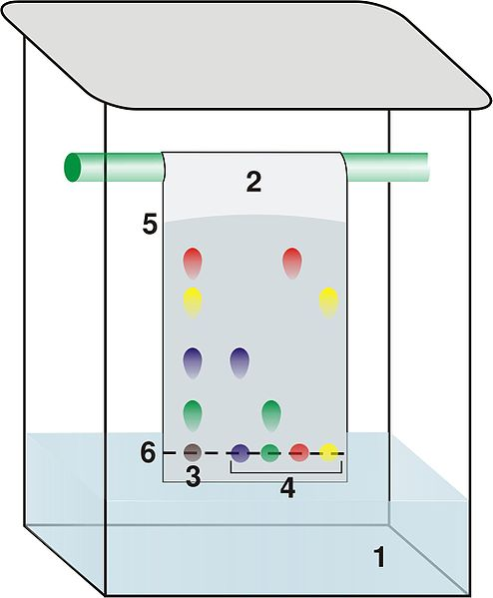

1 - solvent
2 – TLC plate
3 – analyte
4 – pure components
5 – solvent front
6 – point of origin
(Dubaj 2006)

- Gas Chromatography (GC)
  - Used to identify individual heat stable, relatively small molar mass analytes and their concentrations in complex mixtures.
  - Mobile phase is an inert carrier gas such as He or N₂.
  - Stationary phase is a high boiling point non-volatile viscous liquid adsorbed onto solid particles such as silica. This is packed within a long stainless steel coiled column that may be 2-5 mm in diameter and 1.5 – 100 m in length.
  - The gas chromatograph consists of a gas supply, high temperature injection chamber, column, detector and recorder.
  - The liquid mixture to be analysed is injected through a rubber seal and vaporised.
  - The vaporised mixture then travels through the temperature controlled column. The analytes remain either in the mobile phase or stationary phase based on its volatility (tendency to evaporate). Analytes with a higher volatility tend to remain in the mobile phase. These exit (are eluted from) the column quickly and have a smaller retention time.
  - Analytes can be identified by producing a chromatogram of the pure analyte under the same conditions of column choice, carrier gas, gas flow rate and temperature.
  - Analyte concentrations can be determined from the height and area of a chromatogram peak when compared to the peaks produced from a set of standards.

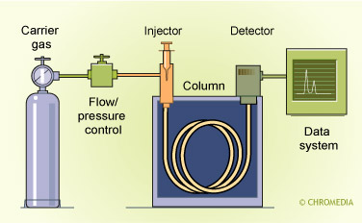

(Snow 2015)

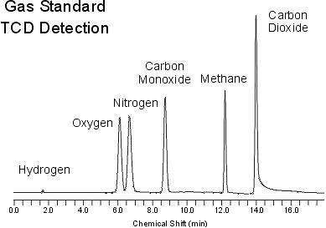

(Thet K n.d.)

- High Performance Liquid Chromatography (HPLC)
  - Used to identify individual, relatively large molar mass analytes which are unstable when heated and their concentrations in complex mixtures.
  - Mobile phase is a non-polar liquid solvent.
  - Stationary phase is made up fine particles such as SiO₂ that are polar. This is packed within a short stainless steel coiled column that may be 3-5 mm in diameter and 10 – 30 cm in length.
  - In reverse phase HPLC the stationary phase is non-polar and the mobile phase is polar.
  - The high performance liquid chromatograph consists of a high pressure pump, sample injection loop, column, detector and recorder.
  - The liquid mixture to be analysed is injected through an injection loop into a high pressure column of solvent.
  - The sample then travels through the column. The analytes travel at different rates through the stationary phase based on their polarity. Analytes with a higher polarity tend to adsorb on to the stationary phase. These take longer to travel through the column and have a larger retention time.
  - Analytes can be identified by producing a chromatogram of the pure analyte under the same conditions of column choice, mobile solvent and solvent flow rate.
  - Analyte concentrations can be determined from the height and area of a chromatogram peak when compared to the peaks produced from a set of standards.
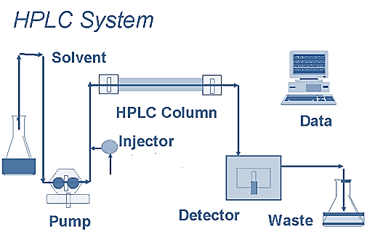

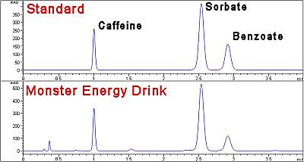
(Chhabra 2013)
Time (min)
absorbance

(ACCTA Inc n.d.)

GASES
Kinetic Theory of Gases
- _________________________________________________________________________________________________________________________________________________________________________________________________________________________________
- _________________________________________________________________________________________________________________________________________________________________________________________________________________________________
- ______________________________________________________________________________________________________________________________________________________
- ______________________________________________________________________________________________________________________________________________________
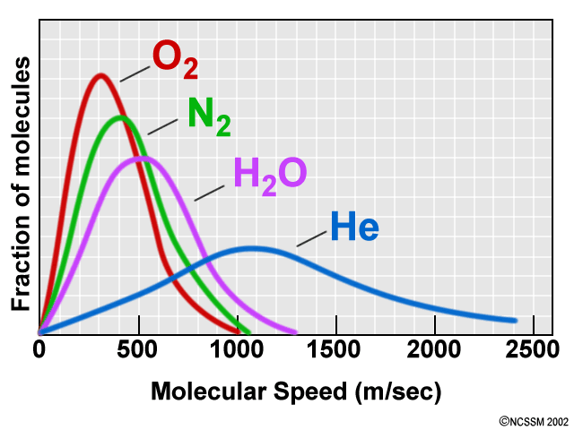
- ______________________________________________________________________________________________________________________________________________________

(North Carolina School of Science and Mathematics n.d.)

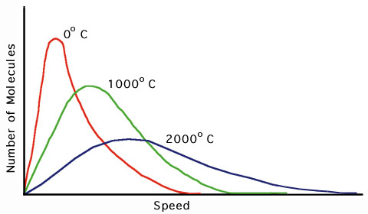

(Casiday R 2000)

Absolute zero
As the temperature of the gas is decreased, the velocity of the particles also decreases. Theoretically, at low enough temperatures, the particles will cease moving. This lowest theoretical temperature is called absolute zero and is equal to ‒273.15 °C or 0 K (Kelvin). To convert K→°C minus 273.15, to convert °C→K add 273.15

The kinetic theory of gases can explain physical properties of gases including:
- Gases diffuse – due to their rapid, random, straight-lined motion and have negligible forces of attraction or repulsion between them.
- Gases are compressible – due to the very large space between them and the particles possessing negligible volume themselves.
- Gases take the shape of the container they are in – due to their rapid, random, straight-lined motion and have negligible forces of attraction or repulsion between them.
- Gases exert pressure – due to their motion, they collide with the container walls (pressure increases with increasing force and frequency of these collisions).
- Gases have a low density – due to the very large spaces between the particles.

Ideal vs real gases
It is important to note that the kinetic theory of gases is based on the notion of an ideal gas. In reality real gases differ from an ideal gas in that real gases:
- Exert forces of attraction and repulsion
- Occupy volume which can be significant when compared to the volume of the gas as a whole
Real gases approach ideal gases under the conditions of high temperature and low pressure.

The nature of gases lends itself to describing a relationship between three properties of a gas; pressure, temperature and volume.

Charles’ law
______________________________________________________________________________ ______________________________________________________________________________
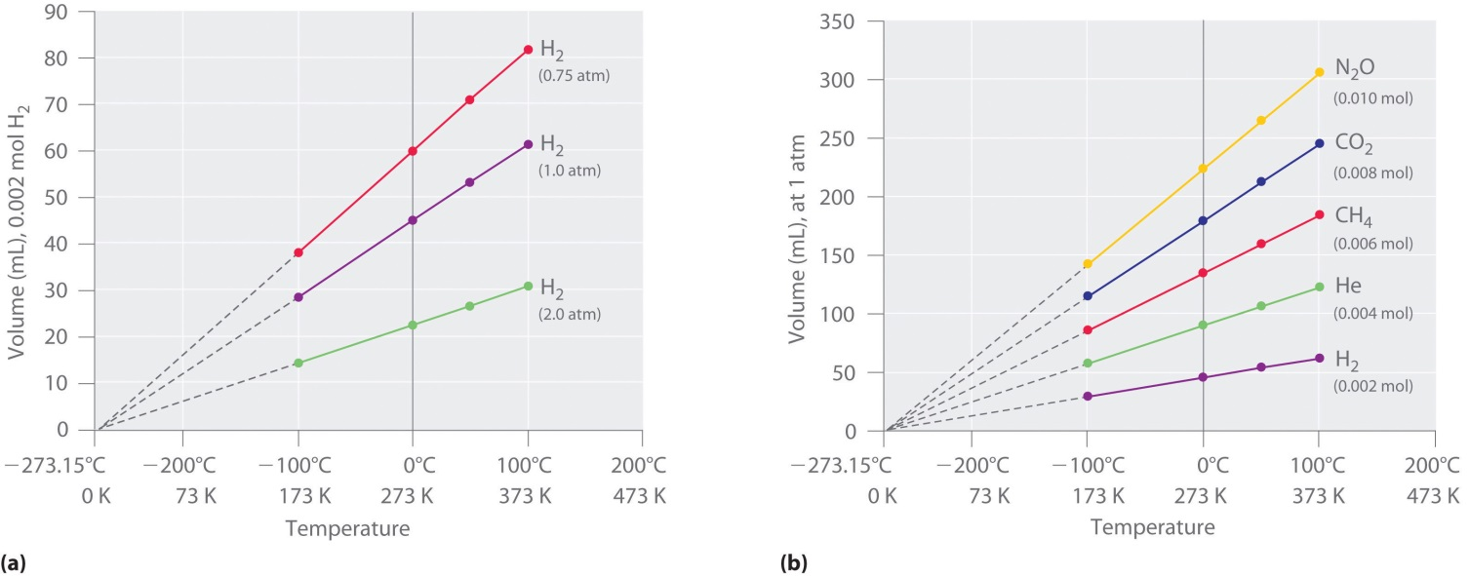

(Schmitz 2012)
Notice that a plot of any gas’ volume as a function of temperature, if extrapolated will intercept the X-axis at absolute zero.
Explain Charles’ law in terms of the kinetic theory ______________________________________ ________________________________________________________________________________________________________________________________________________________________________________________________________________________________________________________________________________________________________________________
Boyle’s law
_________ ____________________________________________________________________ ______________________________________________________________________________
Explain Boyle’s law in terms of the kinetic theory _______________________________________ __________________________________________________________________________________________________________________________________________________________________________________________________________________________________________
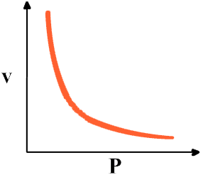
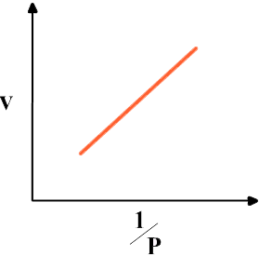

(City Collegiate nd)
Pressure and temperature at constant volume
______________________________________________________________________________ ______________________________________________________________________________

Explain the above relationship in terms of the kinetic theory ______________________________ __________________________________________________________________________________________________________________________________________________________________________________________________________________________________________

Avogadro’s hypothesis
The previous relationships between gas pressure and volume and temperature have assumed a fixed amount of gas and, therefore, the number of particles or moles of gas. This suggests that if the pressure and temperature are kept constant then the number of moles of gas is directly proportional to volume. This is true of all gases because volume is dependent on number of particles, not type of particles.

This fact is reflected in Avogadro’s hypothesis which states that equal volumes of any gas, measured at the same temperature and pressure, contain equal number of particles.
Furthermore, the molar volume of a gas under standard temperature and pressure conditions (ie 273.15 K (or 0 °C) and 100.0 kPa) equals 22.71 L. That is:
Where n = number of moles (n) and V = volume (L).

Bibliography
ACCTA Inc. "Caffeine, Sorbate and Benzate by HPLC." ACCTA. n.d. http://www.accta.com/Methods/sorbate.html (accessed August 2, 2015).
Admin. "Covalent Bond Cartoon Wallpapers." Mass Wallpapers. 2015. http://masswallpapers.mobi/2015/07/covalent-bond-cartoon-wallpapers/ (accessed July 31, 2015).
—. "I See Chromatography Paper Cat Meme." Cat Planet. 2014. http://catplanet.org/i-see-chromatography-paper-cat-meme/ (accessed August 2, 2015).
Burgess, H. "Chemistry - Covalent Bonding and Water." Pintrest. n.d. https://www.pinterest.com/heathergratzer/chemistry-covalent-bonding-water/ (accessed July 29, 2015).
Casiday R, Frey R. "Gas Laws Save Lives: The Chemistry Behind Air Bags." Washington University in St Louis. October 2000. http://www.chemistry.wustl.edu/~edudev/LabTutorials/Airbags/airbags.html (accessed August 2, 2015).
Chhabra, N. "High Performance Liquid Chromatography." Biochemistry for Biomedics. April 15, 2013. http://www.namrata.co/chromatography-2/high-performance-liquid-chromatography/ (accessed August 2, 2015).
Dubaj. "Structural Biochemistry/Chromatography/Thin Layer." Wikibooks. April 29, 2006. https://en.wikibooks.org/wiki/Structural_Biochemistry/Chromatography/Thin_Layer (accessed August 1, 2015).
North Carolina School of Science and Mathematics. "Gases." Teachers' Instructional Graphics Educational Resource. n.d. http://www.dlt.ncssm.edu/tiger/chem3.htm (accessed August 2, 2015).
Ramos, E. "Funny Pictures About Types of Bonds." Pintrest. n.d. https://www.pinterest.com/pin/361202832589039573/ (accessed August 2, 2015).
Schmitz, A. "Relationships Among Pressure, Temperature, Volume and Amount." 2012 Book Archive. December 29, 2012. http://2012books.lardbucket.org/books/principles-of-general-chemistry-v1.0/s14-03-relationships-among-pressure-t.html (accessed August 2, 2015).
Snow, N. "Introduction to Capillary GC injection Technique." Chromedia Analytical Sciences. 2015. http://www.chromedia.org/chromedia?waxtrapp=wlqdcDsHqnOxmOlIEcClBwFjE&subNav=rwhpbjDsHqnOxmOlIEcClBwFjEQ (accessed August 1, 2015).
Thet K, Woo N. "Gas Chromatography." UCDavis Chemwiki. n.d. http://chemwiki.ucdavis.edu/Analytical_Chemistry/Instrumental_Analysis/Chromatography/Gas_Chromatography (accessed August 2015, 2015).

